**CPSC5041 Computing Systems Principles I**

**Homework 2**

**Due: 01/18/2021: Page 1 written portion to be submitted on canvas.**

***(50 Points)***

NOTE: This assignment is to be done individually; you can discuss the problem with your classmates, but you should code your solutions independently.

1. Convert the following decimal numbers to binary. Show your work: (5 + 5)

a) 2021 = 011111100101

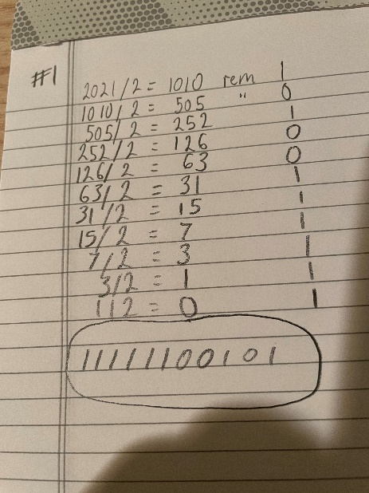

b) 987 = 001111011011

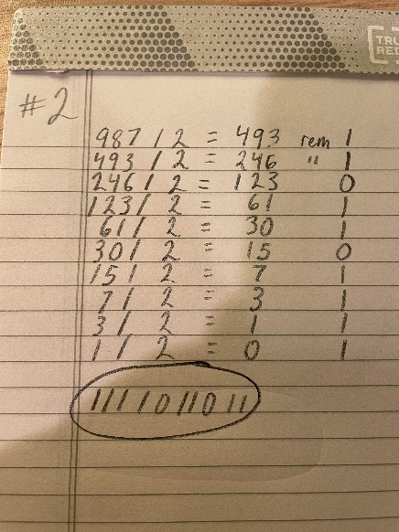

2. Convert the following (unsigned) binary numbers to decimal. Show your work: (5 + 5)

a) 00110001 = 49

b) 10110011 = 179

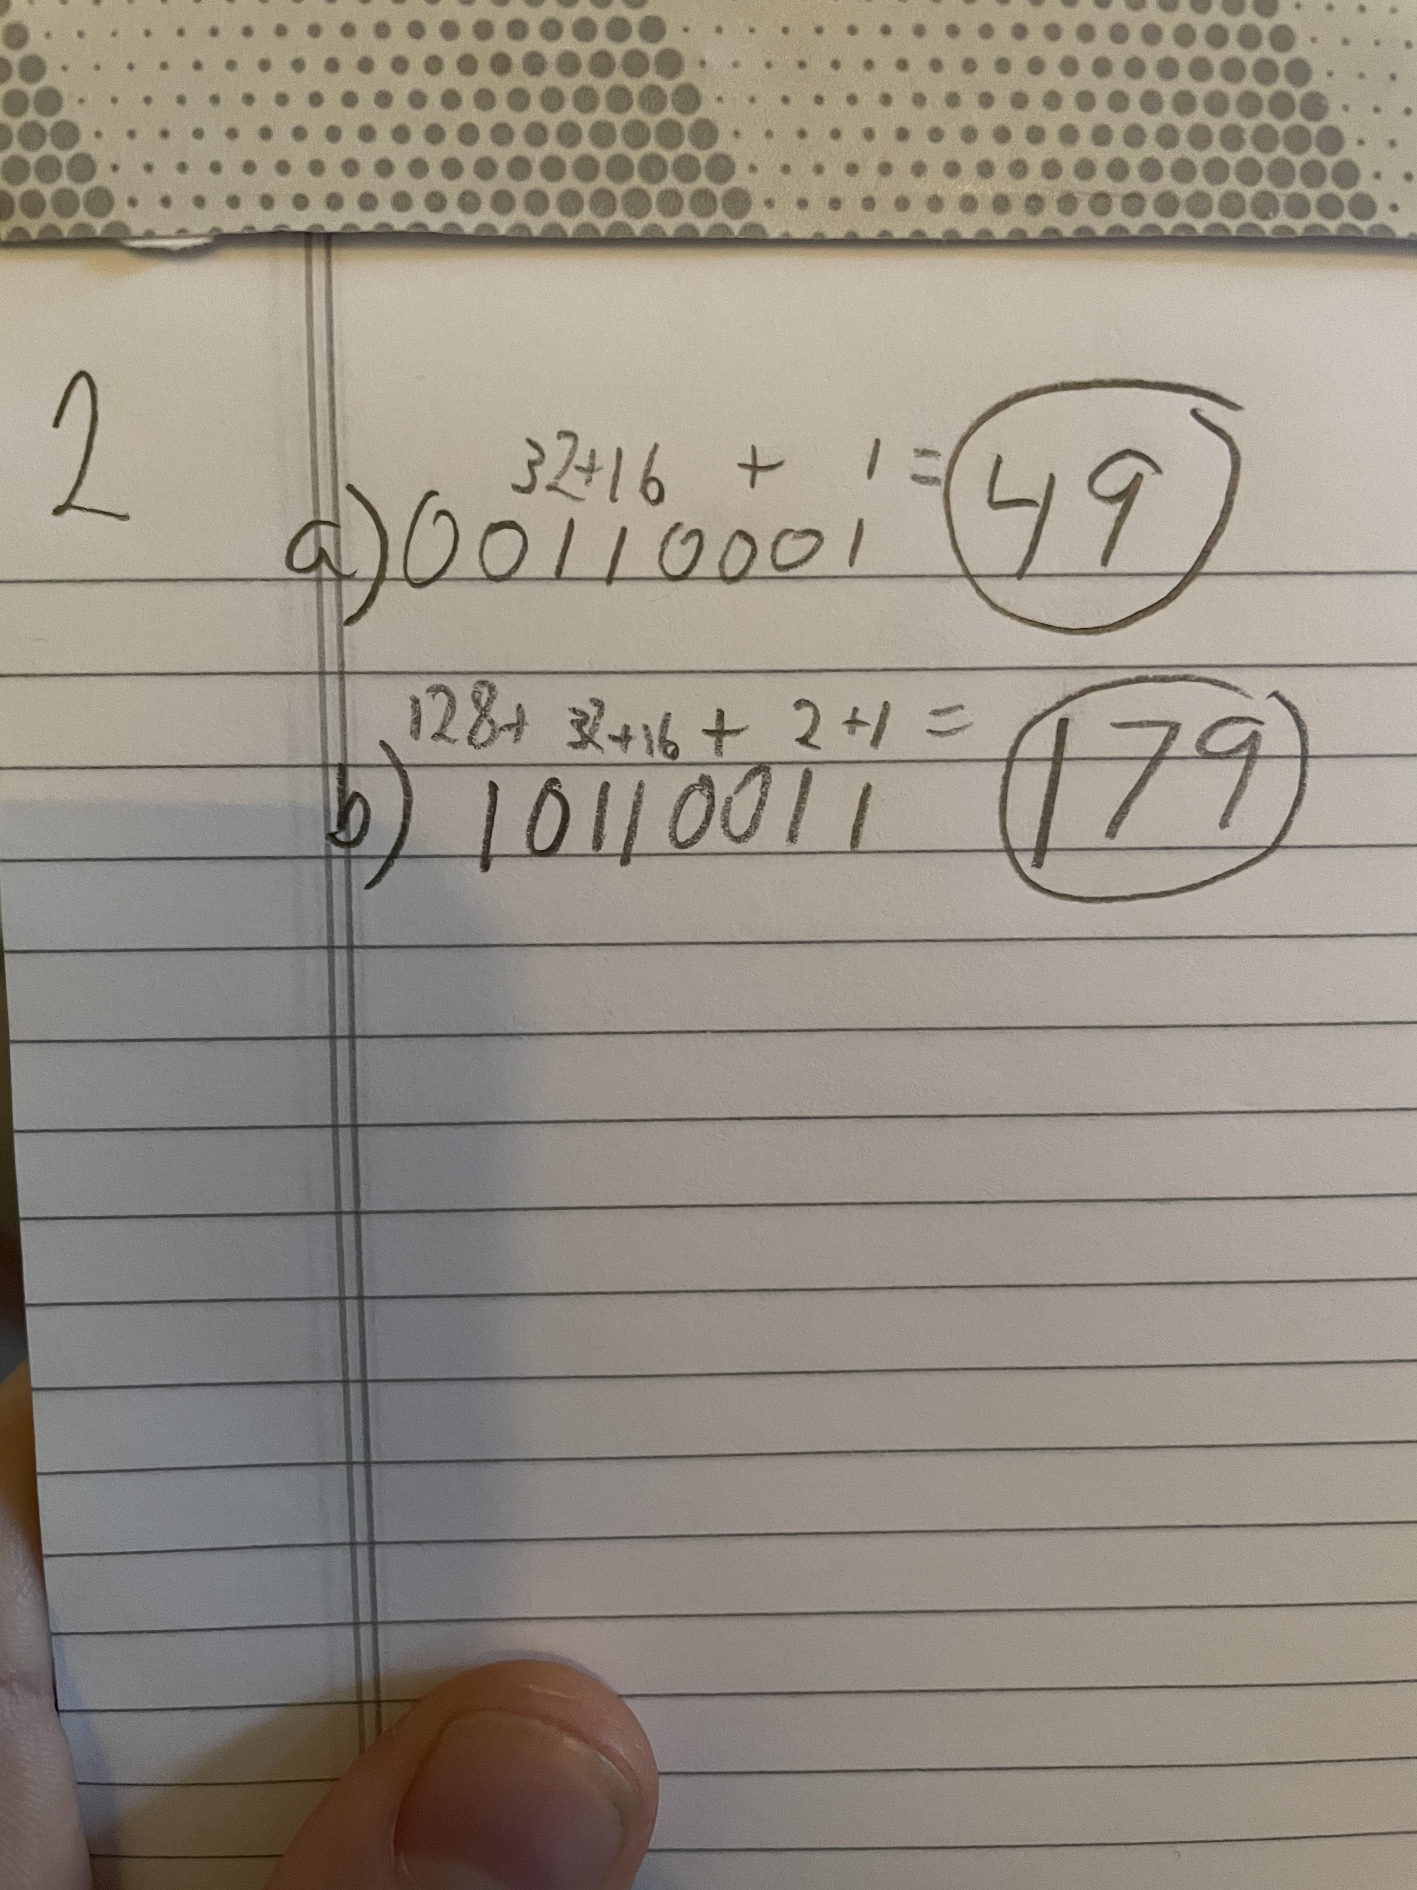

3. In class, we have seen the procedure for expressing decimal numbers in base 2 (binary), and 16 (hexadecimal). In this problem, you need to extend that knowledge to convert the following decimal numbers to different number systems as mentioned below.

Hint: You can employ a method similar to the division method for converting decimal numbers to binary. For converting to base “k,” employ division by k, everything else remains the same. (5 + 5)

a) Convert 80 to base 8 number system. = 120

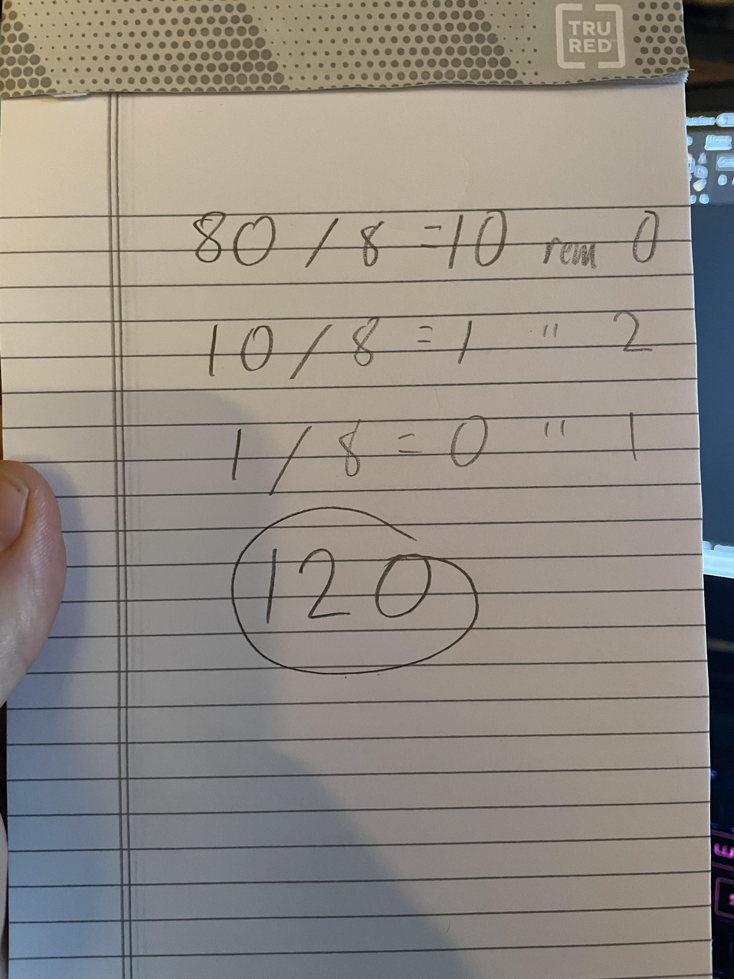

b) Convert 100 to base 7 number system. = 202

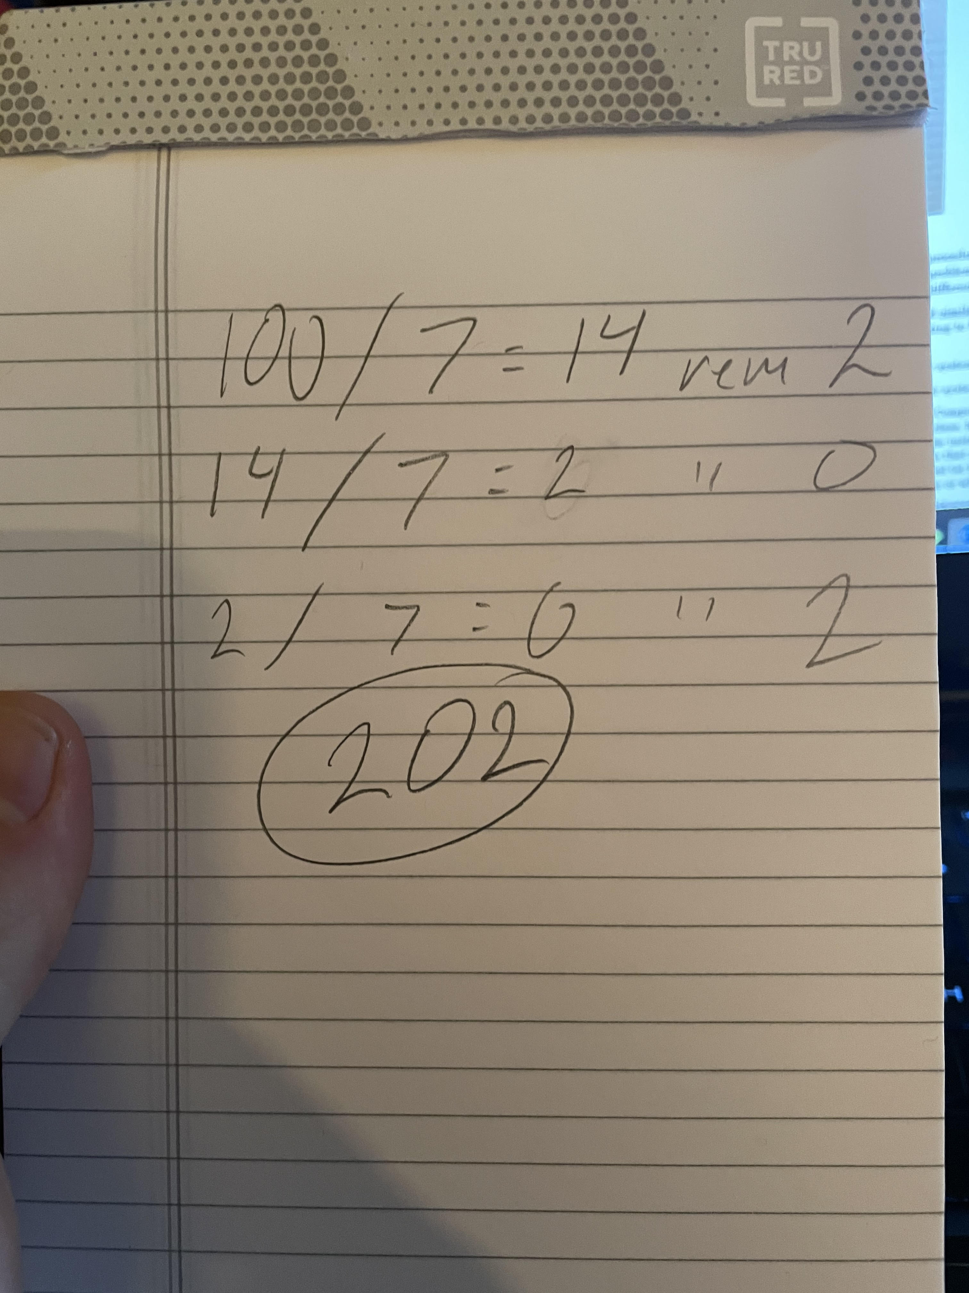

4. For this question refer to the Computer Level Hierarchy on class lecture slides. (available on Canvas). As we discussed in class, level 3 (the Operating System Machine level) is usually a hybrid level. Most of the instructions at this level are also in the ISA level, i.e., level 2. Those level 3 instructions that are identical to level 2’s are executed directly by the microprogram or hardware control (at level 2), not by the operating system (at level 3). Is this a good execution choice? Why or why not? (3 + 7)

Yes, I would say that this is a good execution choice. The lower the level that a set of instructions can be executed, the faster these instructions can be executed. Adding an extra layer of interpretation or translation would unnecessarily slow down the system.

5.Which of the following are valid hexadecimal numbers? (5 + 5)

a) DEAD – Yes, hexadecimal includes all the characters in the word ‘DEAD’

b) AFFECT – No, the character ‘T’ is not included in hexadecimal.